Production Program created.
User Program Name: XXAU Composite Receipt Process
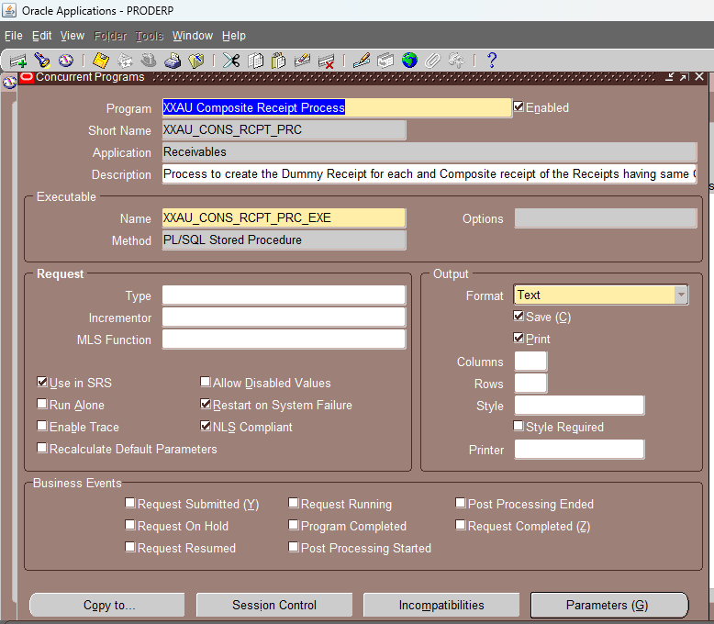

Executable: XXAU_CONS_RCPT_PRC_EXE
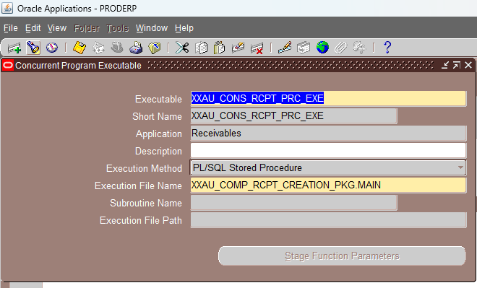

Lookup Name: XXAU_UNIT_CASH_CLEARING
